Deep Learning Environment
(Example RTX3090)

Reference
完整移除舊顯卡驅動和CUDA和CUDNN的方法
https://stackoverflow.com/questions/56431461/how-to-remove-cuda-completely-from-ubuntu

Environment Version
Ubuntu : 18.04.5
Python : 3.6.9
NVIDIA Driver : 455.32.00
CUDA : 11.1
cuDNN : 8.0.5.39-1
Pytorch : 1.7.1
TensorFlow : 2.4.0
Docker : 19.03.6

Install Python
sudo apt install python3
sudo apt install python3-pip

Install NVIDIA Driver
https://www.nvidia.com/zh-tw/geforce/drivers/

sudo bash NVIDIA-Linux-x86_64-455.45.01.run

Install CUDA
https://developer.nvidia.com/cuda-downloads?target_os=Linux&target_arch=x86_64&target_distro=Ubuntu&target_version=1804&target_type=deblocal

wget https://developer.download.nvidia.com/compute/cuda/repos/ubuntu1804/x86_64/cuda-ubuntu1804.pin

sudo mv cuda-ubuntu1804.pin /etc/apt/preferences.d/cuda-repository-pin-600

wget https://developer.download.nvidia.com/compute/cuda/11.1.1/local_installers/cuda-repo-ubuntu1804-11-1-local_11.1.1-455.32.00-1_amd64.deb

sudo dpkg -i cuda-repo-ubuntu1804-11-1-local_11.1.1-455.32.00-1_amd64.deb

sudo apt-key add /var/cuda-repo-ubuntu1804-11-1-local/7fa2af80.pub

sudo apt-get update

sudo apt-get -y install cuda

- 添加環境變數
sudo gedit ~/.bashrc

- 在檔案最後面添加以下內容
export PATH="/usr/local/cuda-11.1/bin:${PATH}"
export LD_LIBRARY_PATH="/usr/local/cuda-11.1/lib64:${LD_LIBRARY_PATH}"

- 啟動環境變數
source ~/.bashrc

Install cuDNN
https://developer.nvidia.com/rdp/cudnn-download

先下載三個deb檔
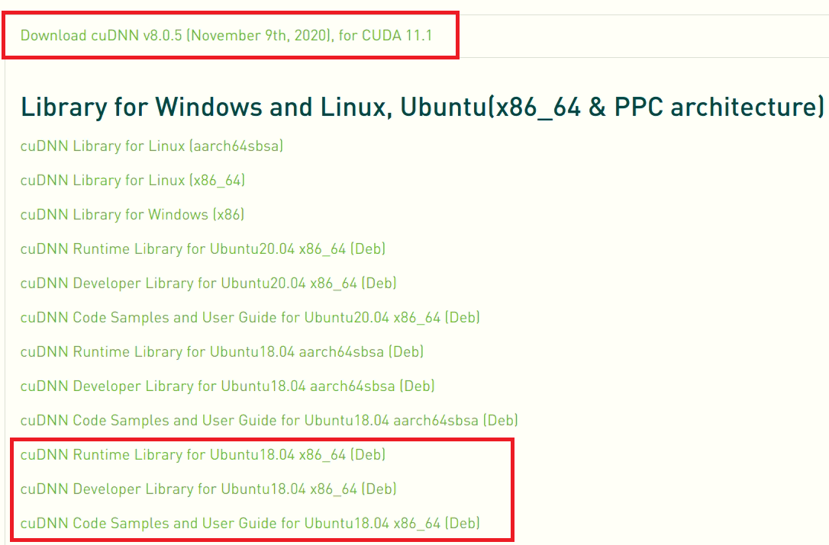

再依照安裝教學下指令
https://docs.nvidia.com/deeplearning/cudnn/install-guide/index.html

sudo dpkg -i libcudnn8_8.0.5.39-1+cuda11.1_amd64.deb
sudo dpkg -i libcudnn8-dev_8.0.5.39-1+cuda11.1_amd64.deb
sudo dpkg -i libcudnn8-samples_8.0.5.39-1+cuda11.1_amd64.deb

Install TensorRT
PyCUDA Install
https://medium.com/leadkaro/setting-up-pycuda-on-ubuntu-18-04-for-gpu-programming-with-python-830e03fc4b81
ONNX Install
https://forums.developer.nvidia.com/t/tensorrt-backend-for-onnx-on-jetson-nano/74980/26

TensorRT Install
https://docs.nvidia.com/deeplearning/tensorrt/install-guide/index.html
https://blog.csdn.net/shwan_ma/article/details/103637739

添加環境變數
sudo gedit ~/.bashrc

在檔案最後面添加以下內容
export LD_LIBRARY_PATH="/usr/local/TensorRT-7.2.2.3/lib:${LD_LIBRARY_PATH}"

啟動環境變數
source ~/.bashrc

Install Pytorch & TensorFlow
pip3 install torch==1.7.1+cu110 torchvision==0.8.2+cu110 torchaudio===0.7.2 -f https://download.pytorch.org/whl/torch_stable.html

pip3 install tensorflow==2.4.0

Install Docker
https://www.hostinger.com/tutorials/install-docker-on-ubuntu/

sudo apt install docker.io

Install Java
https://www.oracle.com/java/technologies/javase-downloads.html

https://askubuntu.com/questions/534658/undo-update-alternatives

